Abhinav Grover

UID -19BCS4606

Batch – CSE -10T2

**DOCUMENTATION**

**AIM -** A visitor counting system with the help of LDR for a hall

**APPARATUS** – Jumper Wires, 2 LDR, 4 Resistors of 10k ohm, 2 LED, Breadboard, Arduino

**SOURCE DIAGRAM-**

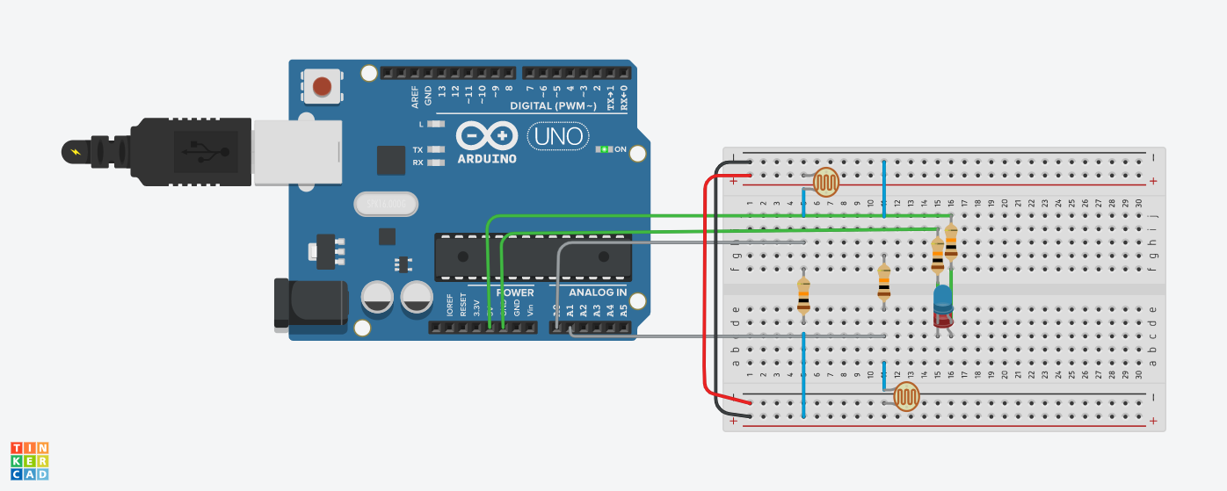

**SOURCE CODE-**

#define LDR_1 A0

#define LDR_2 A1

const int LDR_Min=950;

bool LDR1=LOW;

bool LDR2=LOW;

int PeopleNumber=0;

void setup() {

Serial.begin(9600);

}

void loop() {

if(analogRead(LDR_1)<LDR_Min && analogRead(LDR_2)>LDR_Min && LDR1==LOW && LDR2==LOW)

LDR1=HIGH;

if(analogRead(LDR_1)>LDR_Min && analogRead(LDR_2)<LDR_Min && LDR1==HIGH && LDR2==LOW)

{

while(analogRead(LDR_2)<LDR_Min)

{ }

PeopleNumber++;

Serial.println("People in hall: " + (String)PeopleNumber);

LDR1=LOW;

LDR2=LOW;

}

if(analogRead(LDR_1)>LDR_Min && analogRead(LDR_2)<LDR_Min && LDR1==LOW && LDR2==LOW)

LDR2=HIGH;

if(analogRead(LDR_1)<LDR_Min && analogRead(LDR_2)>LDR_Min && LDR1==LOW && LDR2==HIGH)

{

while(analogRead(LDR_1)<LDR_Min)

{ }

PeopleNumber=PeopleNumber>0?PeopleNumber-1:0;

Serial.println("People in hall: " + (String)PeopleNumber);

LDR2=LOW;

LDR1=LOW;

}

}

**PRECAUTIONS –**

**1)**Always use the Arduino without plugging it.

**2)**Don’t touch the energized wires and equipment.

**3)**Use Jumper Wires having straight pins at their ends.

**4)**Use resistors of correct ohm.

**RESULT-**

People in room:1

From LDR1 to LDR2 [Entrance]

People in room:2

People in room:3

People in room:4

From LDR2 to LDR1 [Exit]

People in room:3

People in room:2

People in room:1